Exercise 1: Create and configure Azure resources

Task 1: Open the Azure portal

1. On the taskbar, select the **Microsoft Edge** icon.
2. In the browser window, browse to the Azure portal at https://portal.azure.com, and then sign in with the account you'll be using for this lab.

**Note**: If this is your first time signing in to the Azure portal, you'll be offered a tour of the portal. Select **Get Started** to skip the tour and begin using the portal.

Task 2: Create an Application Insights resource

1. In the Azure portal, use the **Search resources, services, and docs** text box at the top of the page to search for **Application Insights** and then, in the list of results, select **Application Insights**.
2. On the **Application Insights** blade, select **+ Create**.
3. On the **Application Insights** blade, on the **Basics** tab, perform the following actions, and select **Review + create**:

| **Setting** | **Action** |
| --- | --- |
| **Subscription** drop-down list | Retain the default value |
| **Resource group** section | Select **MonitoredAssets** |
| **Name** text box | **instrm52386244** |
| **Region** drop-down list | westus2 |
| **WORKSPACE DETAILS** section | Retain the default values for the **Subscription** and **Log Analytics Workspace** drop-down lists |

1. The following screenshot displays the configured settings on the **Application Insights** blade.
2. 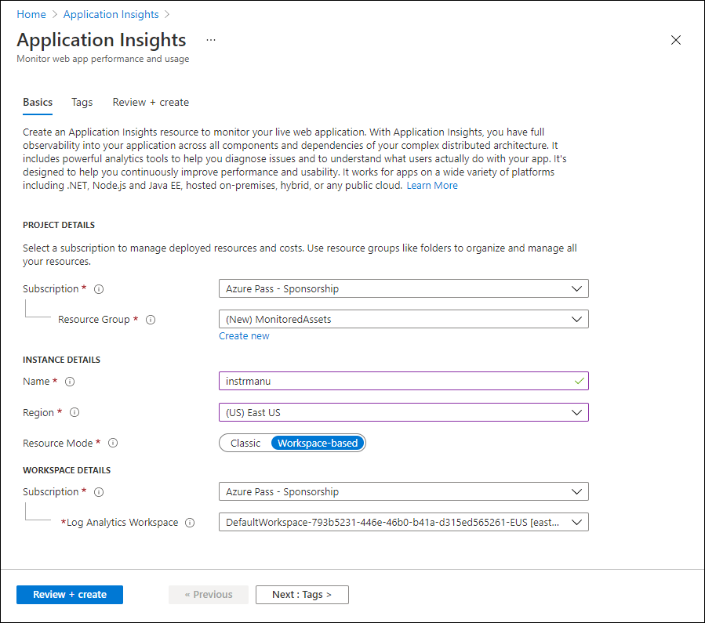
3. On the **Review + create** tab, review the options that you selected during the previous steps.
4. Select **Create** to create the **Application Insights** instance by using your specified configuration.

**Note**: Wait for the creation task to complete before you proceed with this lab.

1. On the **Microsoft.AppInsights | Overview** blade, select the **Go to resource** button to navigate to the blade of the newly created **Application Insights** resource.
2. On the **Application Insights** blade, in the **Configure** section, select the **Properties** link.
3. On the **Properties** blade, next to the **Instrumentation Key** entry, select the **Copy to clipboard** button, and then record the copied value. You'll use it later in this lab.

**Note**: The key is used by client applications to connect to a specific **Application Insights** resource.

Task 3: Create an Azure Web API resource

1. In the Azure portal, use the **Search resources, services, and docs** text box at the top of the page to search for **App Services** and then, in the list of results, select **App Services**.
2. On the **App Services** blade, select **+ Create**, and then select **+ Web App**.
3. On the **Create Web App** blade, on the **Basics** tab, perform the following actions, and then select the **Monitor + secure** tab:

| **Setting** | **Action** |
| --- | --- |
| **Subscription** drop-down list | Retain the default value |
| **Resource group** drop-down list | Select **MonitoredAssets** |
| **Name** text box | enter smpapi52386244 |
| **Publish** section | Select **Code** |
| **Runtime stack** drop-down list | Select **.NET 8 (LTS)** |
| **Operating System** section | Select **Windows** |
| **Region** drop-down list | westus2 |
| **Windows Plan (Region)** section | Select **Create new**, in the **Name** text box, enter MonitoredPlan, and then select **OK** |
| **Pricing plan** section | Retain the default value |

1. On the **Monitor + secure** tab, perform the following actions, and then select **Review + create**:

| **Setting** | **Action** |
| --- | --- |
| **Enable Application Insights** section | Ensure that **Yes** is selected |
| **Application Insights** drop-down list | Select the **instrm52386244** Application Insights resource that you created previously in this lab |

1. On the **Create Web App** tab, review the options that you selected during the previous steps.
2. Select **Create** to create the web API by using your specified configuration.

**Note**: Wait for the creation task to complete before you proceed with this lab.

1. On the deployment **Overview** blade, select the **Go to resource** button to navigate to the blade of the newly created Azure web API.
2. On the **App Service** blade, in the **Settings** section, select the **Environment Variables** link.
3. In the **Environment Variables** section, perform the following actions:
   1. On the **App settings** tab, select **Show values** to display secrets associated with your web API.
   2. Note the value representing the **APPLICATIONINSIGHTS_CONNECTION_STRING** key. This value was set automatically when you built the web API resource.
4. On the **App Service** blade, select **Overview** at the top of the service menu.
5. On the **App Service** blade, in the **Essentials** section, record the value of the **Default domain** link. You'll use this value later in the lab to submit requests to the web API.

Task 4: Configure web API autoscale options

1. On the **App Service** blade, in the **Settings** section, select the **Scale out (App Service Plan)** link.
2. Scroll down until you see the **Scale out method**. Select the **Rules Based** option, then select **Configure**.

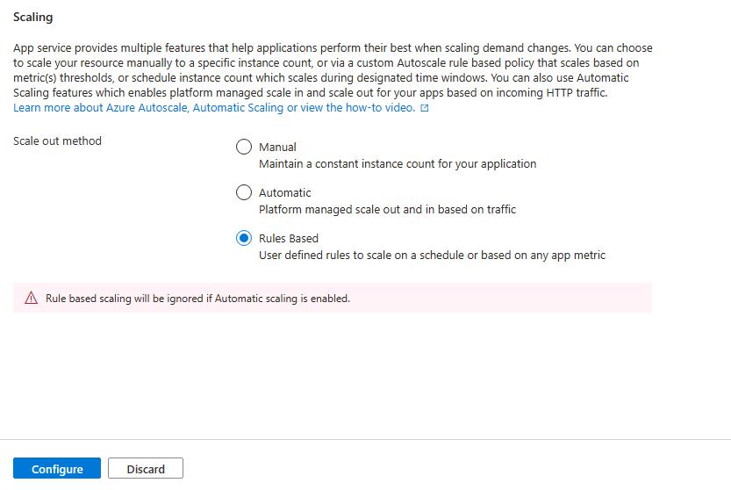

1. In the **Scale out** section, perform the following actions, and then select **Save**:

| **Setting** | **Action** |
| --- | --- |
| **Scale out** section | Select **Custom autoscale** |
| **Autoscale setting name** text box | enter ComputeScaler |
| **Resource group** drop-down list | Select **MonitoredAssets** |
| **Scale mode** section | Select **Scale based on a metric** |
| **Minimum** text box in the **Instance limits** section | enter 1 |
| **Maximum** text box in the **Instance limits** section | enter 8 |
| **Default** text box in the **Instance limits** section | enter 3 |

1. The following screenshot displays the configured settings in the **Scale out** section on the **App Service** blade.
2. 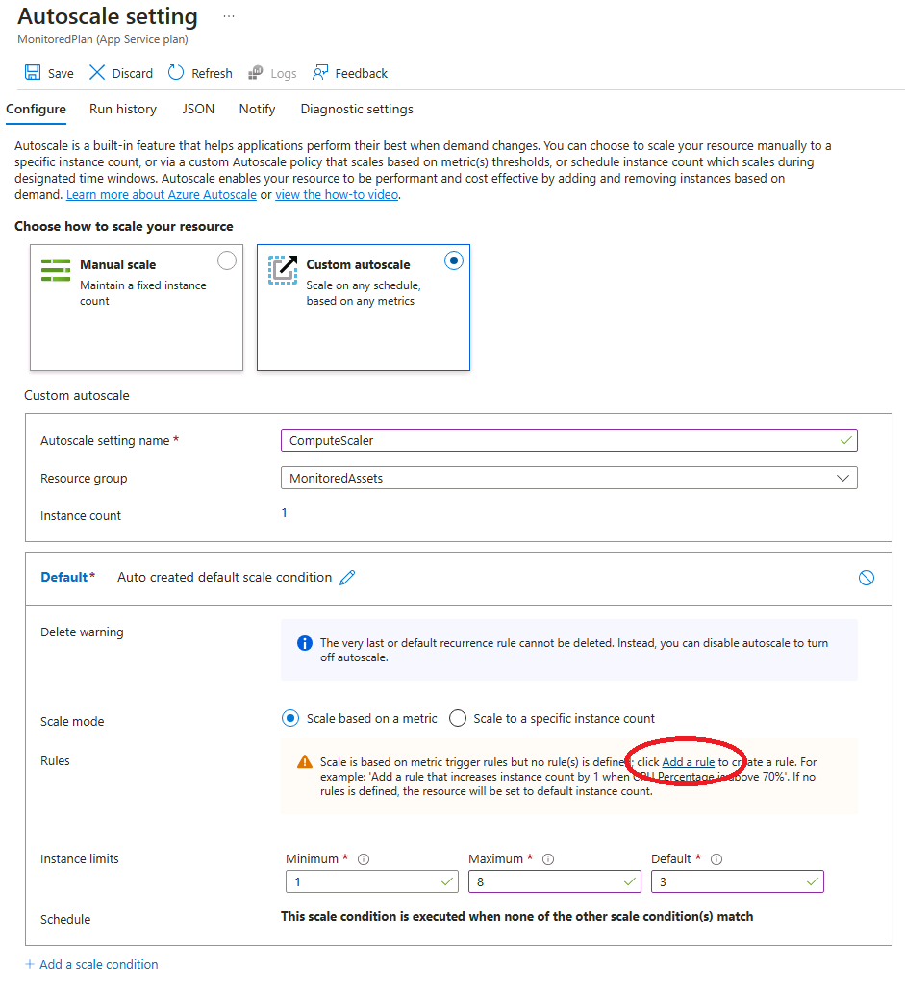

| **Setting** | **Action** |
| --- | --- |
| **Rules** section | Select **Add a rule** |
| **Scale rule** blade | Retain default values for all settings, and then select **Add** |

1. The following screenshot displays additional settings in the **Scale out** section on the **App Service** blade.
2. 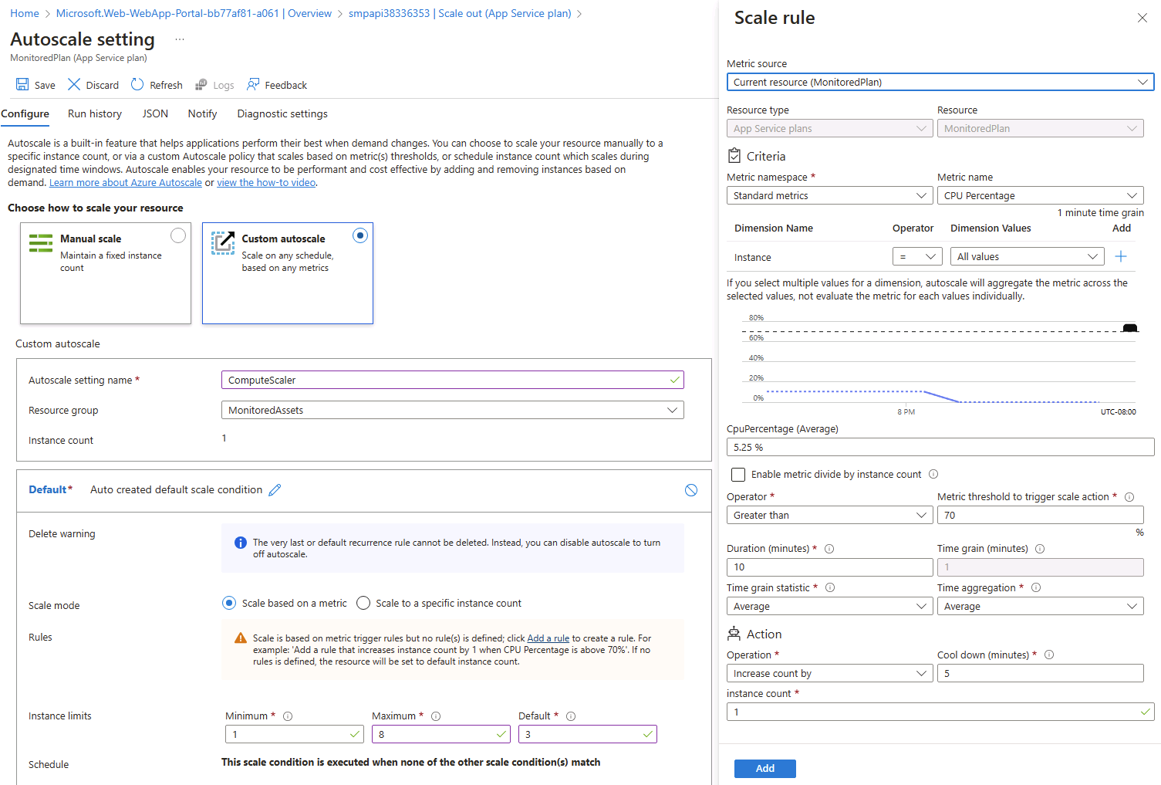
3. **Note**: Wait for the save operation to complete before you continue with this lab.

Review

In this exercise, you created the Azure resources that you'll use for the remainder of the lab.

Exercise 2: Monitor a local web API by using Application Insights

Task 1: Build a .NET Web API project

1. From the lab computer, start **Visual Studio Code**.
2. In Visual Studio Code, on the **File** menu, select **Open Folder**.
3. In the **Open Folder** window, browse to **Allfiles C:\Allfiles\Labs\11\Starter\Api**, and then select **Select Folder**.
4. In the **Visual Studio Code** window, on the Menu Bar, select **Terminal** and then select **New Terminal\***.
5. At the terminal prompt, run the following command to create a new .NET Web API application named **SimpleApi** in the current directory:

dotnet new webapi --output . --name SimpleApi --framework net8.0

1. Run the following command to import version 2.21.0 of **Microsoft.ApplicationInsights** from NuGet to the current project:

dotnet add package Microsoft.ApplicationInsights --version 2.21.0

**Note**: The **dotnet add package** command will add the **Microsoft.ApplicationInsights** package from NuGet. For more information, refer to [Microsoft.ApplicationInsights](https://www.nuget.org/packages/Microsoft.ApplicationInsights/).

1. Run the following command to import version 2.21.0 of **Microsoft.ApplicationInsights.AspNetCore** from NuGet:

dotnet add package Microsoft.ApplicationInsights.AspNetCore --version 2.21.0

**Note**: The **dotnet add package** command will add the **Microsoft.ApplicationInsights.AspNetCore** package from NuGet. For more information, refer to [Microsoft.ApplicationInsights.AspNetCore](https://www.nuget.org/packages/Microsoft.ApplicationInsights.AspNetCore).

1. At the terminal prompt, run the following command to import version 2.21.0 of **Microsoft.ApplicationInsights.PerfCounterCollector** from NuGet to the current project:

dotnet add package Microsoft.ApplicationInsights.PerfCounterCollector --version 2.21.0

**Note**: The **dotnet add package** command will add the **Microsoft.ApplicationInsights.PerfCounterCollector** package from NuGet. For more information, refer to [Microsoft.ApplicationInsights.PerfCounterCollector](https://www.nuget.org/packages/Microsoft.ApplicationInsights.PerfCounterCollector/).

1. At the terminal prompt, run the following command to import version 2.4.0 of **Microsoft.ApplicationInsights.Profiler.AspNetCore** from NuGet to the current project:

dotnet add package Microsoft.ApplicationInsights.Profiler.AspNetCore --version 2.4.0

**Note**: The **dotnet add package** command will add the **Microsoft.ApplicationInsights.Profiler.AspNetCore** package from NuGet. For more information, refer to [Microsoft.ApplicationInsights.Profiler.AspNetCore](https://www.nuget.org/packages/Microsoft.ApplicationInsights.Profiler.AspNetCore/).

1. At the terminal prompt, run the following command to build the .NET Web API:

dotnet build

Task 2: Update app code to disable HTTPS and use Application Insights

1. In the **Visual Studio Code** window, on the **Explorer** pane, select the **Program.cs** file to open the file on the **editor** pane.
2. On the **editor** pane, locate and delete the following code in line 17:

csharp

app.UseHttpsRedirection();

**Note**: This line of code forces the web API to use HTTPS. For this lab, this is unnecessary.

1. In the **Program.cs** file, add the following two lines starting with line 7 to enable Profiler by registering it along with Application Insights into the Service collection:

csharp

builder.Services.AddApplicationInsightsTelemetry();

builder.Services.AddServiceProfiler();

1. Save the changes and close the **Program.cs** file.
2. In the **Visual Studio Code** window, on the **Explorer** pane, select the **appsettings.json** file to open the file on the **editor** pane.
3. Add to the **appsettings.json** file the following element right after the **Logging** element, replacing the instrumentation-key placeholder with the value of the Application Insights resource instrumentation key that you recorded earlier in this lab:

json

"ApplicationInsights":

{

"InstrumentationKey": "instrumentation-key"

},

**Note**: If the section you are adding is the last element of the file, remove the trailing comma.

1. Your appsettings.json file should now look similar in structure to the following:

json

{

"Logging":{

"LogLevel": {

"Default": "Information",

"Microsoft.AspNetCore": "Warning"

}

},

"ApplicationInsights":

{

"InstrumentationKey": "instrumentation-key"

},

"AllowedHosts": "*"

}

**Note** Ensure you have replaced the placeholder with your own instrumentation key that you recorded earlier.

1. Save the changes to the **appsettings.json** file and close it.
2. At the terminal prompt, run the following command to build the .NET Web API.

dotnet publish -c Release -r win-x86 --self-contained -p:PublishReadyToRun=true .\SimpleApi.csproj

Task 3: Test an API application locally

1. At the terminal prompt, run the following command to launch the .NET Web API.

dotnet run

1. Review the output of the command and note the HTTP URL that the site is listening on.
2. From the taskbar, open the context menu for the **Microsoft Edge** icon, and then open a new browser window.
3. In the browser window that opens, navigate to the http://localhost URL and add the **/weatherforecast** relative path of your web API.

**Note**: The full URL is http://localhost:[port-number]/weatherforecast, where the [port-number] placeholder identifies the port number at which the web app is accessible via the HTTP protocol.

**Note**: The page should contain an output in the following format. The actual values **will** be different.

json

[

{

"date": "2023-10-29",

"temperatureC": -8,

"summary": "Sweltering",

"temperatureF": 18

},

{

"date": "2023-10-30",

"temperatureC": -12,

"summary": "Hot",

"temperatureF": 11

},

{

"date": "2023-10-31",

"temperatureC": 50,

"summary": "Chilly",

"temperatureF": 121

},

{

"date": "2023-11-01",

"temperatureC": 51,

"summary": "Chilly",

"temperatureF": 123

},

{

"date": "2023-11-02",

"temperatureC": 29,

"summary": "Balmy",

"temperatureF": 84

}

]

1. Refresh the browser page a number of times to simulate some responses.
2. Close the browser window that's displaying the page generated by http://localhost:[port-number]/weatherforecast.
3. In Visual Studio Code, select **Kill Terminal** (the **Recycle Bin** icon) to close the **terminal** pane and any associated processes.

Task 4: Review metrics in Application Insights

1. On your lab computer, switch to the **Microsoft Edge** browser window displaying the Azure portal.
2. In the Azure portal, navigate back to the blade of the **instrm52386244** Application Insights resource you created previously in this lab.
3. On the **Application Insights** blade, in the tiles in the center of the blade, find the displayed metrics. Specifically, find the number of server requests that have occurred and the average server response time.

The following screenshot displays the **Application Insights** metrics of the local web app.

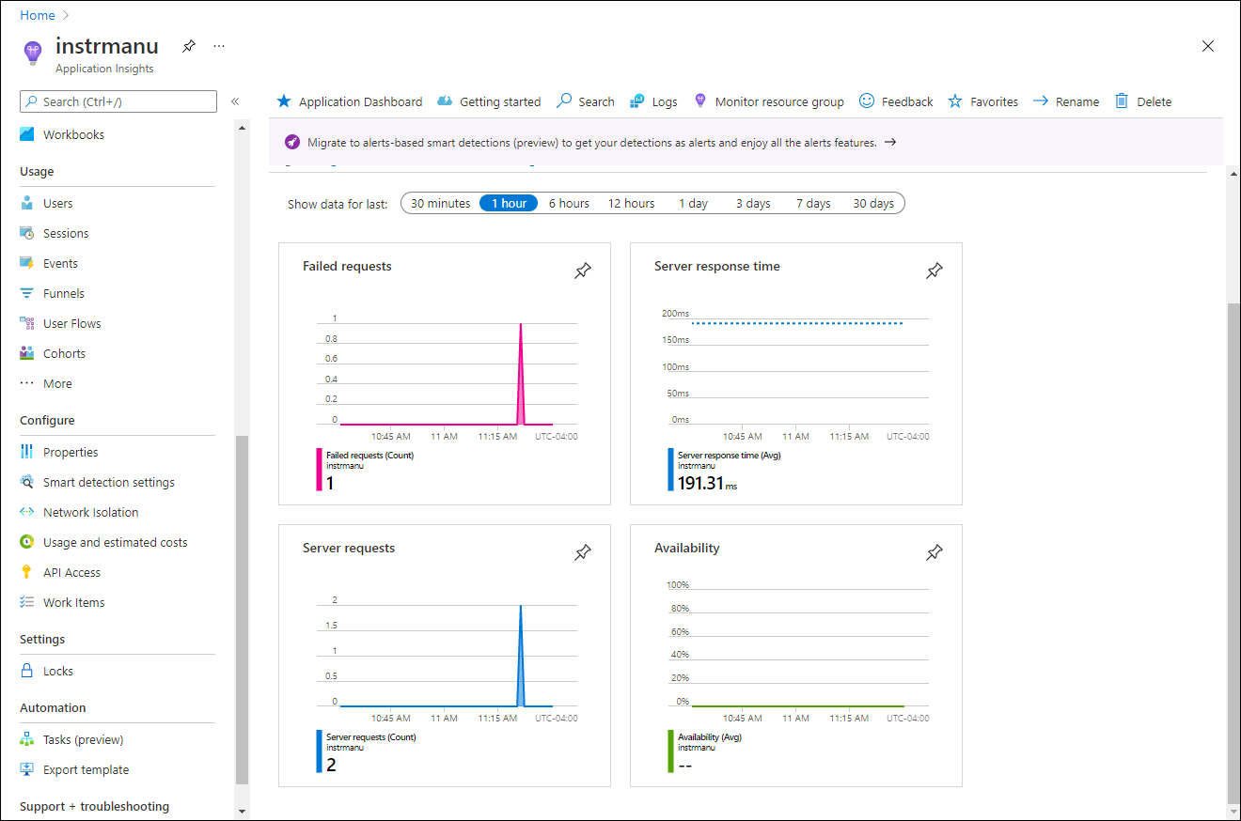

**Note**: It can take up to five minutes to observe requests in the Application Insights metrics charts.

Review

In this exercise, you created an API app by using ASP.NET and configured it to stream application metrics to Application Insights. You then used the Application Insights dashboard to review performance details about your API.

Exercise 3: Monitor a web API using Application Insights

Task 1: Deploy an application to the web API

1. On the lab computer, switch to the Visual Studio Code.
2. In the **Visual Studio Code** window, on the Menu Bar, select **Terminal** and then select **New Terminal**.
3. At the terminal prompt, run the following command to ensure that the current directory is set to the **Allfiles C:\Allfiles\Labs\11\Starter\Api\bin\Release\net8.0\win-x86\publish**, where the deployment files reside:

cd C:\Allfiles\Labs\11\Starter\Api\bin\Release\net8.0\win-x86\publish\

1. Run the following command to create a zip file containing the starter project that you'll deploy next to the Azure web API:

powershell

Compress-Archive -Path * -DestinationPath api.zip

1. At the terminal prompt, run the following command to sign in to your Azure subscription by using Azure PowerShell:

powershell

Connect-AzAccount

1. When prompted, authenticate by providing the credentials to access the Azure subscription you are using for this lab.

**Note**: Wait for the sign-in process to complete.

1. Run the following command to display the listing of all web apps in the **MonitoredAssets** resource group:

powershell

Get-AzWebApp -ResourceGroupName MonitoredAssets

1. Run the following command to display the list of web apps in the **MonitoredAssets** resource group, which names start with **smpapi\***:

powershell

Get-AzWebApp -ResourceGroupName MonitoredAssets | Where-Object {$_.Name -like 'smpapi*'}

1. Run the following commands to display the name of the first of the web apps identified in the previous step and store it in a variable named **$webAppName**:

powershell

Get-AzWebApp -ResourceGroupName MonitoredAssets | Where-Object {$_.Name -like 'smpapi*'} | Select-Object -ExpandProperty Name

$webAppName = (Get-AzWebApp -ResourceGroupName MonitoredAssets | Where-Object {$_.Name -like 'smpapi*'})[0] | Select-Object -ExpandProperty Name

1. Run the following command to deploy the **api.zip** file you created previously in this task to the web API whose name you identified in the previous step:

powershell

Publish-AzWebApp -ResourceGroupName MonitoredAssets -Name $webAppName -ArchivePath "C:\Allfiles\Labs\11\Starter\Api\bin\Release\net8.0\win-x86\publish\api.zip" -force

**Note**: Wait for the deployment to complete before you continue with this lab.

1. On the lab computer, launch another Microsoft Edge browser window.
2. In the browser window, navigate to the Azure Web API app into which you deployed the API app previously in this task by appending to its URL (that you recorded previously in this lab) the suffix **/weatherforecast**.

**Note**: For example, if your URL is https://smpapianu.azurewebsites.net, the new URL would be https://smpapianu.azurewebsites.net/weatherforecast.

1. Verify that the output resembles the one generated when running the API app locally.

**Note**: The output will include different values but it should have the same format.

Task 2: Configure in-depth metric collection for Web Apps

1. On your lab computer, switch to the **Microsoft Edge** browser window displaying the Azure portal.
2. In the Azure portal, navigate back to the blade of the **smpapi52386244** web app resource you created previously in this lab.
3. On the **App Service** blade, select **Application Insights**.
4. On the **Application Insights** blade, perform the following actions, select **Apply**, and then in the confirmation dialog, select **Yes**:

| **Setting** | **Action** |
| --- | --- |
| **Application Insights** slider | Ensure it is set to **Enable** |
| **Instrument your application** section | Select the **.NET** tab |
| **Collection level** section | Select **Recommended** |
| **Profiler** section | Select **On** |
| **Snapshot debugger** section | Select **Off** |
| **SQL Commands** section | Select **Off** |

1. The following screenshot displays the **Application Insights** settings of the Azure Web API.
2. 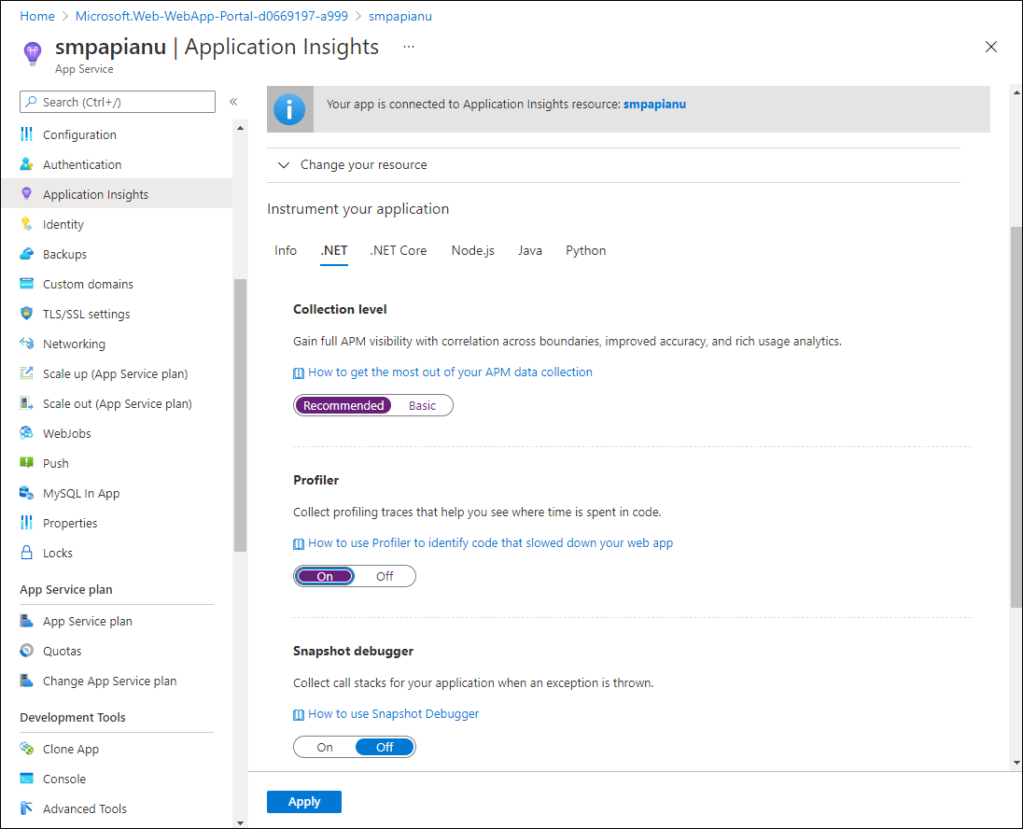
3. Switch to the browser tab you opened in the previous task to display the results of deployment of your API app to the target Azure API app (including the **/weatherforecast** relative path in the target URL) and refresh the browser page several times.
4. Review the JSON-formatted output generated by the API.
5. Record the URL that you used to access the JSON-formatted output.

**Note**: The URL should be in the format https://smpapianu.azurewebsites.net/weatherforecast if **smpapianu** was the site name you created earlier.

Task 3: Get updated metrics in Application Insights

1. Return to the browser window displaying the Azure web app in the Azure portal.
2. On the **Application Insights** blade of the web app, select the **View Application Insights data** link.
3. On the **Application Insights** blade, review the collected metrics in the tiles in the center of the blade, including the number of server requests that have occurred and the average server response time.

The following screenshot displays the **Application Insights** metrics of the Azure web app in the Azure portal.

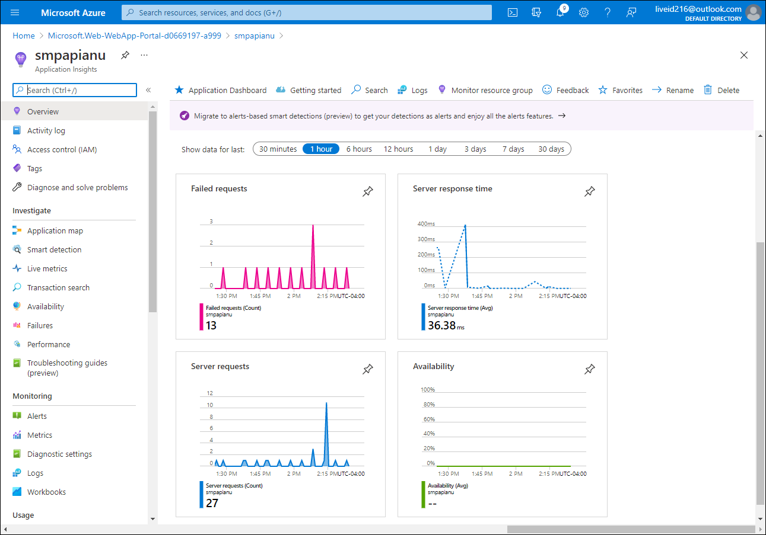

**Note**: It can take up to five minutes for updated metrics to appear in the Application Insights metrics charts.

Task 4: View real-time metrics in Application Insights

1. On the **Application Insights** blade, in the **Investigate** section, select **Live metrics**.
2. Switch back to the browser window displaying the target API app running in the target Azure web app (which targets the **/weatherforecast** relative path in the target URL), and then refresh the browser page several times.
3. Switch to the browser window displaying the **Live metrics** blade and review its content.

**Note**: The **Incoming Requests** section should update within seconds, showing the requests that you made to the web API.

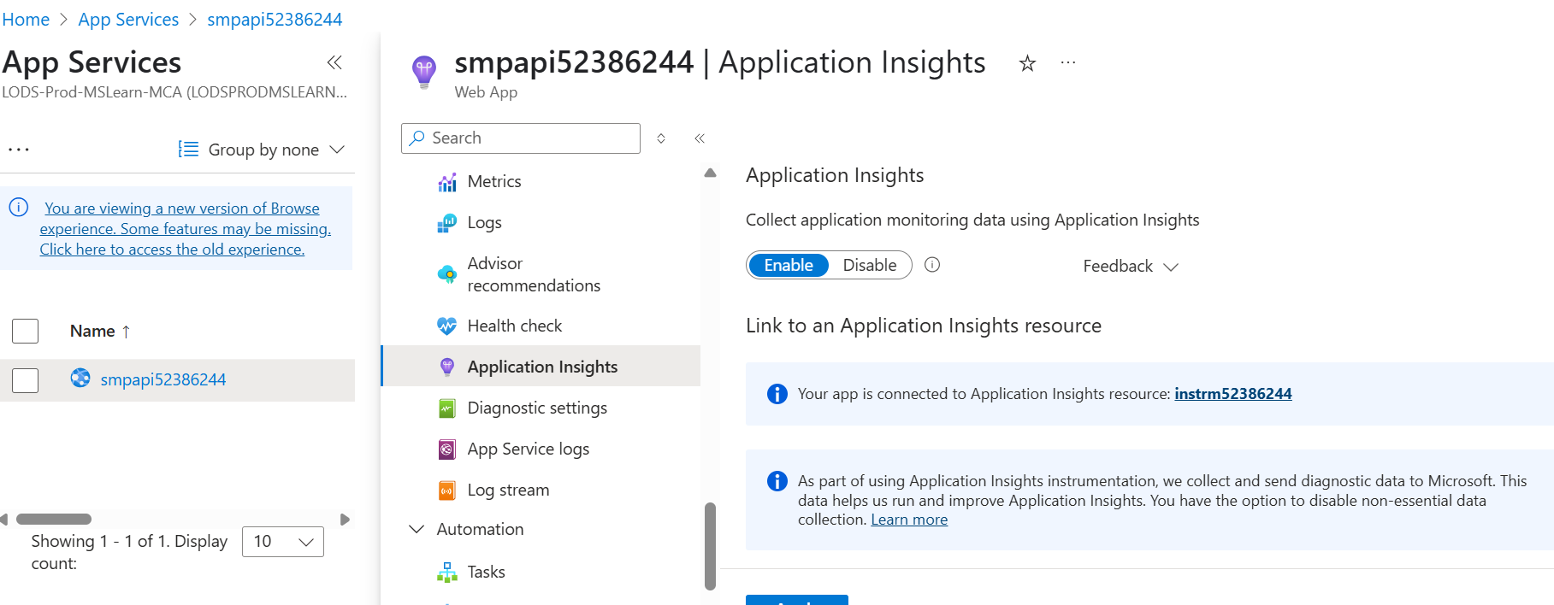

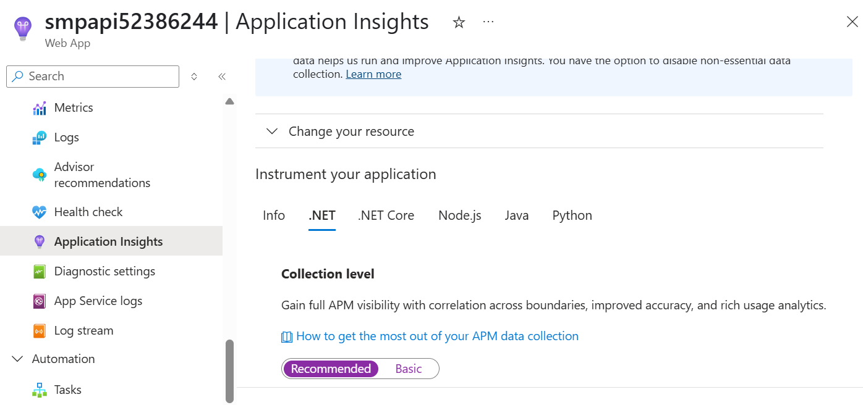

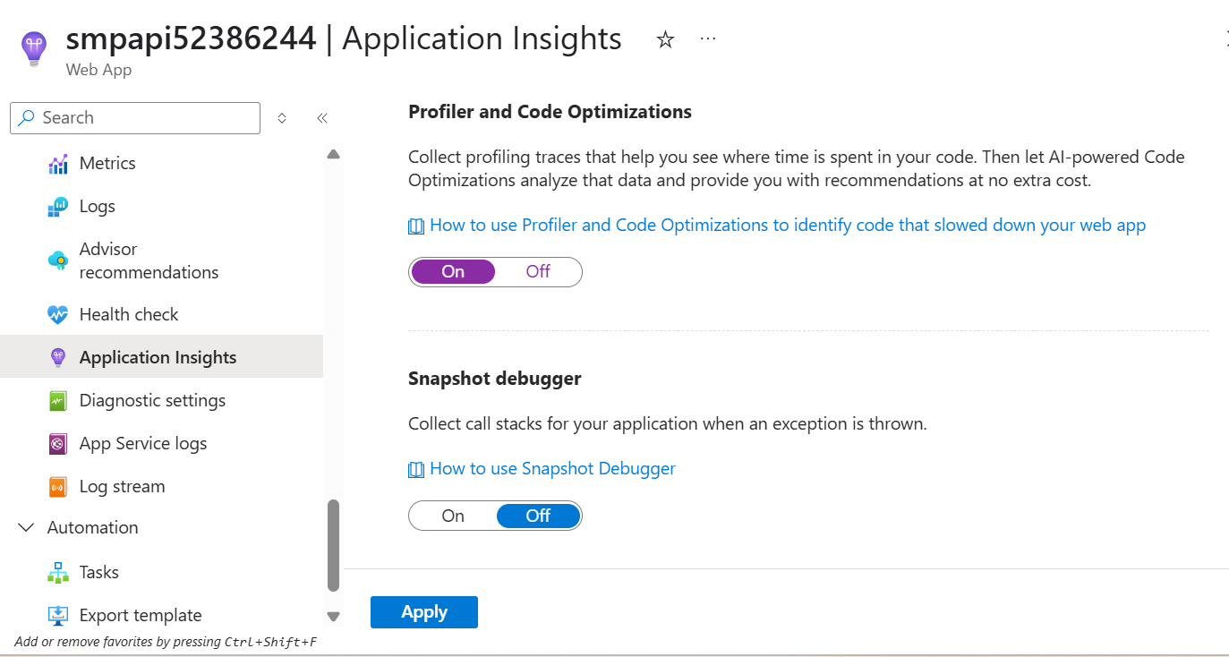

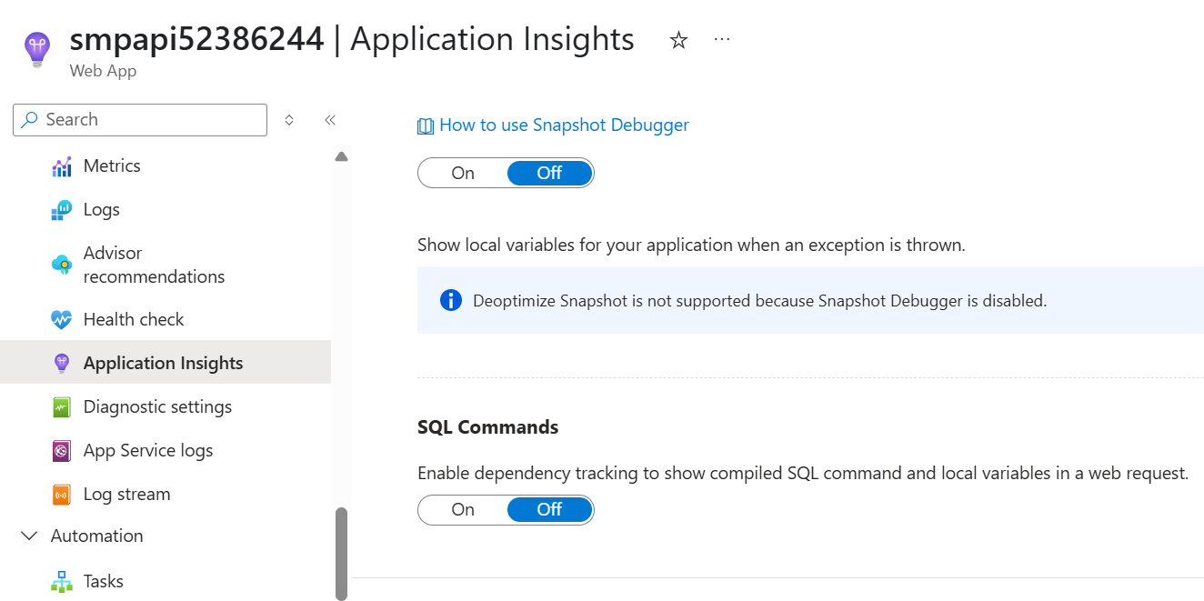

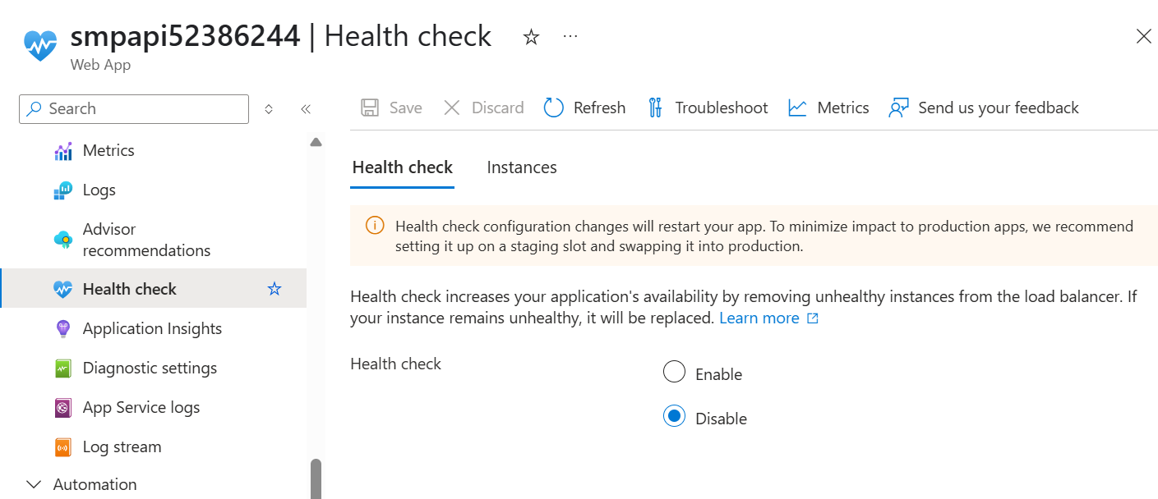

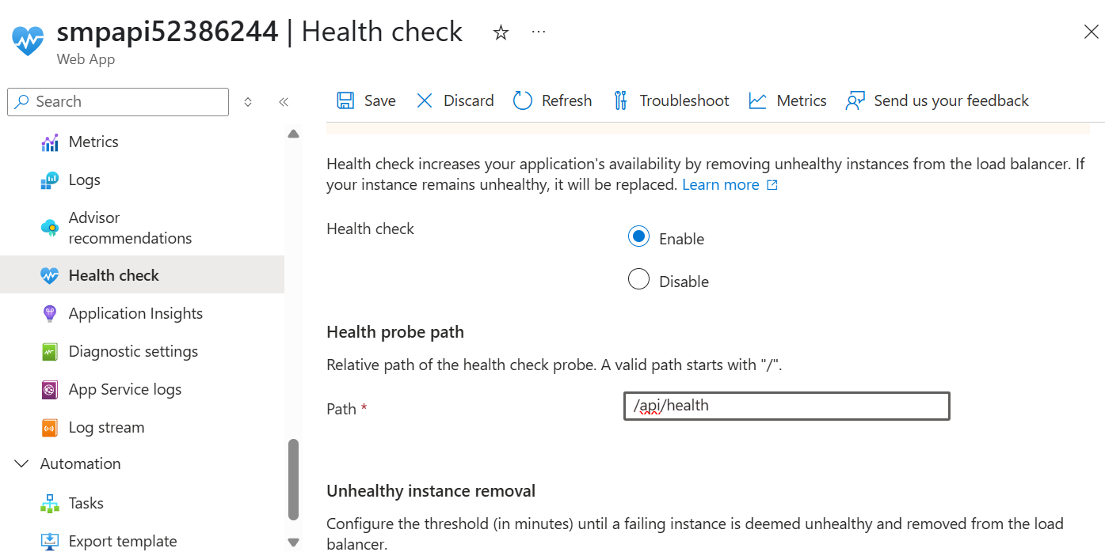

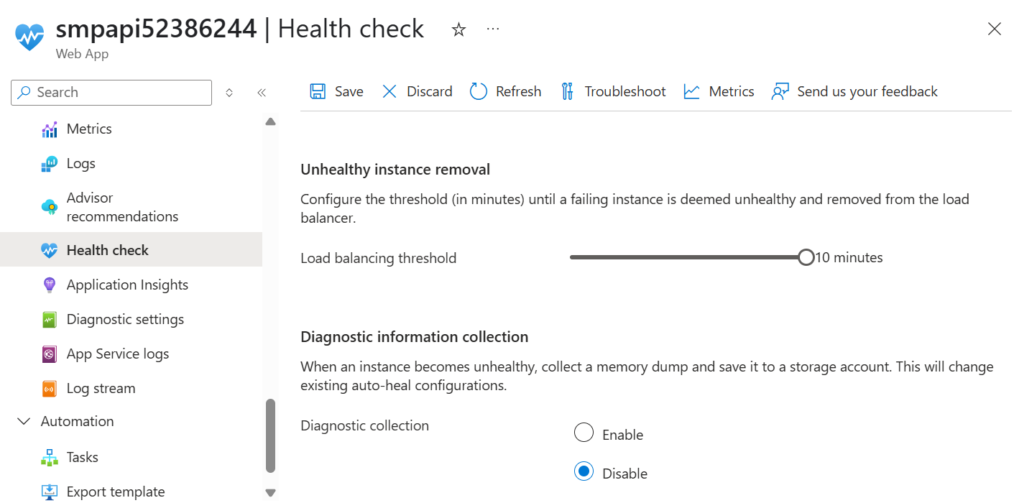

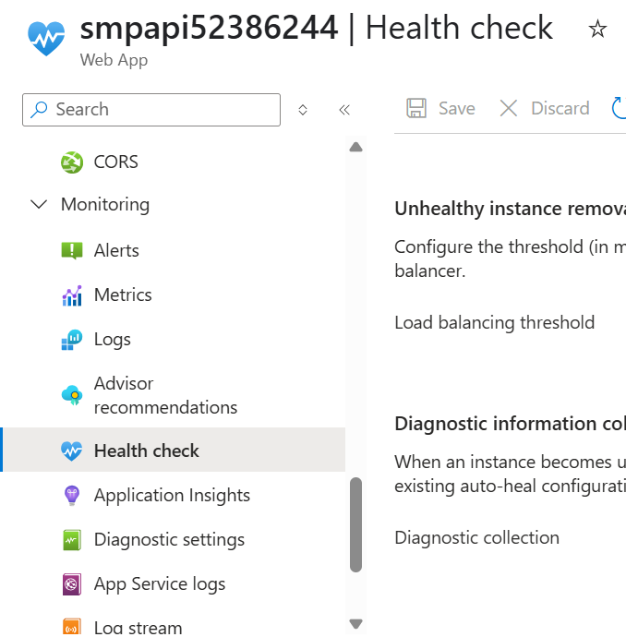

**Required NuGet Packages**Ensure you have the following NuGet package installed:  
1. *Microsoft.Extensions.Diagnostics.HealthChecks  
2. AspNetCore.HealthChecks.SqlServer  
3. AspNetCore.HealthChecks.UI  
4. AspNetCore.HealthChecks.UI.Client  
5. AspNetCore.HealthChecks.UI.InMemory.Storage  
6. AspNetCore.HealthChecks.Uris*

**Note:** I have separately created a file called**HealthCheck.cs** , and implemented all the health check configurations.

**a. Database Health Check**

The database health check is a crucial aspect of monitoring the well-being of your application, especially when it relies on a database for storing and retrieving data. This health check ensures that the database is not only reachable but also responsive to queries.

**HealthCheck.cs**

public static void ConfigureHealthChecks(this IServiceCollection services,IConfiguration configuration)  
{  
 services.AddHealthChecks()  
 .AddSqlServer(configuration["ConnectionStrings:DefaultConnection"], healthQuery: "select 1", name: "SQL Server", failureStatus: HealthStatus.Unhealthy, tags: new[] { "Feedback", "Database" });  
  
 //services.AddHealthChecksUI();  
 services.AddHealthChecksUI(opt =>  
 {  
 opt.SetEvaluationTimeInSeconds(10); //time in seconds between check   
 opt.MaximumHistoryEntriesPerEndpoint(60); //maximum history of checks   
 opt.SetApiMaxActiveRequests(1); //api requests concurrency   
 opt.AddHealthCheckEndpoint("feedback api", "/api/health"); //map health check api   
  
 })  
 .AddInMemoryStorage();  
}

**configuration["ConnectionStrings:DefaultConnection"]**This retrieves the connection string from your configuration, allowing flexibility in configuring the database connection.  
**failureStatus: HealthStatus.Unhealthy**This indicates that if the health check fails, the overall health status should be marked as unhealthy.

**Program.cs**Configure the *ConfigureHealthChecks()* inside the *program.cs*

//Congiguring Health Ckeck  
builder.Services.ConfigureHealthChecks(builder.Configuration);  
  
//HealthCheck Middleware  
app.MapHealthChecks("/api/health", new HealthCheckOptions()  
{  
 Predicate = _ => true,  
 ResponseWriter = UIResponseWriter.WriteHealthCheckUIResponse  
});  
app.UseHealthChecksUI(delegate (Options options)   
{  
 options.UIPath = "/healthcheck-ui";  
 options.AddCustomStylesheet("./HealthCheck/Custom.css");  
  
});

<https://medium.com/@jeslurrahman/implementing-health-checks-in-net-8-c3ba10af83c3>

**b. Remote Endpoints Health Check**

Next, we’ll implement a health check for remote endpoints and memory.  
**RemoteHealthCheck.cs**

using Microsoft.Extensions.Diagnostics.HealthChecks;  
using System;  
using System.Net.Http;  
using System.Threading;  
using System.Threading.Tasks;  
  
namespace FeedbackService.Api  
{  
 public class RemoteHealthCheck : IHealthCheck  
 {  
 private readonly IHttpClientFactory _httpClientFactory;  
 public RemoteHealthCheck(IHttpClientFactory httpClientFactory)  
 {  
 _httpClientFactory = httpClientFactory;  
 }  
 public async Task<HealthCheckResult> CheckHealthAsync(HealthCheckContext context, CancellationToken cancellationToken = new CancellationToken())  
 {  
 using (var httpClient = _httpClientFactory.CreateClient())  
 {  
 var response = await httpClient.GetAsync("https://api.ipify.org");  
 if (response.IsSuccessStatusCode)  
 {  
 return HealthCheckResult.Healthy($"Remote endpoints is healthy.");  
 }  
  
 return HealthCheckResult.Unhealthy("Remote endpoint is unhealthy");  
 }  
 }  
 }  
}

**b. Memory Health Check**

Finally, let’s implement a health check to monitor the memory status of the API service.

**MemoryHealthCheck.cs**

using System;  
using System.Collections.Generic;  
using System.Linq;  
using System.Threading;  
using System.Threading.Tasks;  
using Microsoft.Extensions.Diagnostics.HealthChecks;  
using Microsoft.Extensions.Options;  
  
namespace FeedbackService.Api.HealthCheck  
{  
 public class MemoryHealthCheck : IHealthCheck  
 {  
 private readonly IOptionsMonitor<MemoryCheckOptions> _options;  
  
 public MemoryHealthCheck(IOptionsMonitor<MemoryCheckOptions> options)  
 {  
 _options = options;  
 }  
  
 public string Name => "memory_check";  
  
 public Task<HealthCheckResult> CheckHealthAsync(  
 HealthCheckContext context,  
 CancellationToken cancellationToken = default(CancellationToken))  
 {  
 var options = _options.Get(context.Registration.Name);  
  
 // Include GC information in the reported diagnostics.  
 var allocated = GC.GetTotalMemory(forceFullCollection: false);  
 var data = new Dictionary<string, object>()  
 {  
 { "AllocatedBytes", allocated },  
 { "Gen0Collections", GC.CollectionCount(0) },  
 { "Gen1Collections", GC.CollectionCount(1) },  
 { "Gen2Collections", GC.CollectionCount(2) },  
 };  
 var status = (allocated < options.Threshold) ? HealthStatus.Healthy : HealthStatus.Unhealthy;  
  
 return Task.FromResult(new HealthCheckResult(  
 status,  
 description: "Reports degraded status if allocated bytes " +  
 $">= {options.Threshold} bytes.",  
 exception: null,  
 data: data));  
 }  
 }  
 public class MemoryCheckOptions  
 {  
 public string Memorystatus { get; set; }  
 //public int Threshold { get; set; }  
 // Failure threshold (in bytes)  
 public long Threshold { get; set; } = 1024L * 1024L * 1024L;  
 }  
}